BLACK FAMILY GENEALOGY AND HISTORY SOCIETY
MINUTES OF THE JULY 2026 BUSINESS MEETING
SATURDAY, JULY 11, 2026, 10:00AM (Arizona Time)
ZOOM ROOM
JERYSE KELLY – PRESIDENT

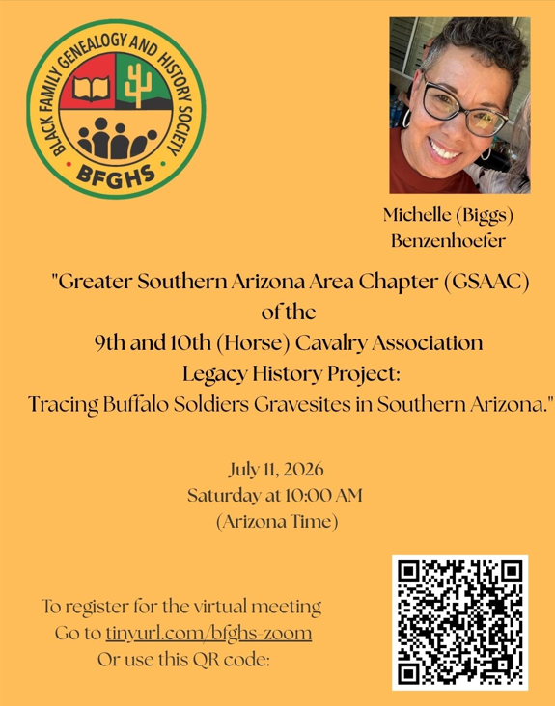
MEMBERS PRESENT
Guests:
Sharon Kennedy and Frank Bothwell - Guests of the speaker, Michelle Benzenhoefer
Karen Routt – Redwood, CA
Janeen Russell –Vail, AZ
Jelisa Marshall – Guest of Helen Poole
Christine Rhodes
Dr. Faith Thomas

Members:
Mike Ostler, Debbie Ostler, NiyeNinu White, Arlene Everett, Birtie Owens, Marie Scott, Michelle Benzenhoefer (speaker), Paulette Howard, Phyllis Grimes, Ann Hines, Jeryse Kelly, Dr. Anthony Pratcher, Margaret Hangan, Cheryl Franks, Helen Poole, Isaiah Shamsiddeen, Jonda Shamsiddeen, Kathy Farretta, Ma-Li Metcalf, Evan Senat, Gayle King.

AGENDA

9:55 a.m. – 10:00 a.m. – Guidelines for Virtual Presentation & Meeting – Social Media – IT Committee
[NOTE: Attendance - Members and Guests, please type your names into the “Chat” box.]
10:00 – 10:02 a.m. – Meeting is called to Order & Welcome … Jeryse Kelly, President
10:02 – 10:05 a.m. – Greetings
10:05 – 10:15 a.m. – Guest Introductions

10:15 - 10:17 a.m. – Introduction of Speaker – Marie Scott, Chairperson, Program Committee

10:17 – 11:20 a.m. – [Vicky Daviss-Mitchell Presenter’s Series]
"GSAAC Legacy History Project:
Tracing Buffalo Soldiers Gravesites in Southern Arizona." by
Michelle (Biggs) Benzenhoefer

Southwest Association of Buffalo Soldiers
Dmbenzen@gmail.com - Speakers email address
Arlene Everett stated that the Buffalo Soldiers participated in the Civil War and in the Philippines
AZ91hcav.org - the organization's website. However, that website can't be found. The current official website is buffalosoldiersmuseum.org

11:20 – 11:35 a.m. – Q & A … Members and Guests (Questions must be placed in the “Chat” box).

11:35 – 11:38 a.m. – Poll Regarding Presentation … Zoom

11:38 – 12:00 p.m. – Committee reports
• Membership – Paulette Howard
- Her trip to Angola Africa was phenomenal
- Currently, we have 53 members.
- Still looking for a contact person for ASU grads.
- Contact with Alpha Phi Alpha
- Meeting with The National Council of Women on 8/1/26.
- Vacation Bible School w/First Institutional Baptist Church
- Next membership meeting will be July 16, 2026, at 7PM via Zoom.
- Roscoe Smith –Frat brother would like to meet with Paulette Howard.

• Programming – Marie Scott
- Jeryse Kelly reminded us of the upcoming trip to Tucson, AZ. There will be a tour
The African American Museum, Lunch, the Buffalo Soldier Memorial and Research.
- The cost of the van is $120.00 per person. RSVP by 7/18,2026, please. 12 have responded so far.
- Marie Scott – 8/26/26 at 2PM with member John Spearman via Zoom on Marie Scott's Zoom account.
- Kate Guertz, Friday, September 18, 2026, at the LDS Center, 2707 S. College St., Tempe, AZ. An Evite will be sent to the members.
- We have a presenter for October.
es
• Treasurer - Absent

• Minutes –Gayle King, Recording Secretary
- Difficulty sending emails. Per Jeryse Kelly, the BFGHS email is not working. Please use the board members' private email addresses.

• Corresponding Secretary – Mike Ostler
- Evan Senat worked with Debbie and Mike on a project.
- More volunteers are needed for this project.

• SM/IT - Website – Jeryse Kelly
- Members are encouraged to create their profile on the updated BFGHS website.
- Events and Contacts to be added to the Calendar.
- Volunteers are needed.

12:00 – 12:25 p.m. – Birthdays, Member Highlight, Announcements, Research time.

Birthdays

Phyllis Grimes – 7/1
Beverly Hart – 7/2
Ann Hines – 7/4
Dr. Anthony Pratcher – 7/6
Paula Green - 7/18
Debbie Ostler – 7/22

Talk Time

- Black Newspapers of Arizona
- Call Libraries to set up time for research
- Join Facebook Genealogy Groups
- 1827 – NY-The Freedom's Journal, the first African American Newspaper
- Read news to other Blacks that can't read

Question- What is holding you from writing, sharing and publishing your story?
Use AI to help record
ChatGPT

10 million project

12:25 – 12:30 p.m. – Closing and Adjournment

Adjourned 12:30PM

Respectfully Submitted,

Gayle L King
Recording Secretary
August 15, 2026

